# SIMULATION OF MODEL

To simulate your model on real time follow following steps:

1. Connect Arduino to computer. MATLAB will show that it has detected Arduino.
2. For first time use we have to programme Arduino before Simulink. For that Go to ADD ONs>MANAGE ADD ONs. You will see set up option for MATLAB support package for Arduino hardware. Programme Arduino for USB Connection. OR directly type “Arduinosetup” in MATLAB window.
   1. Choose USB type connection and connect Arduino to laptop.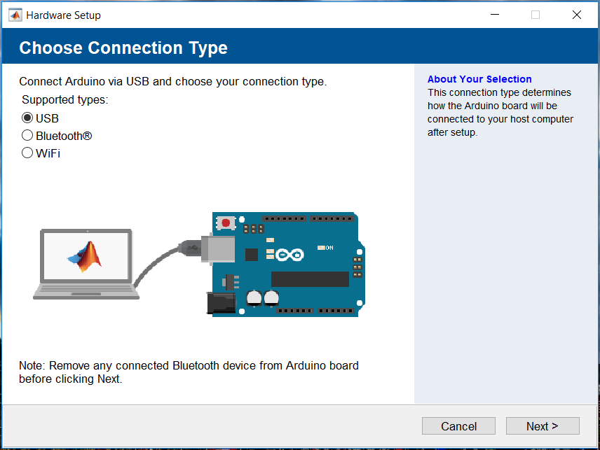
   2. Choose Board type and its Com port.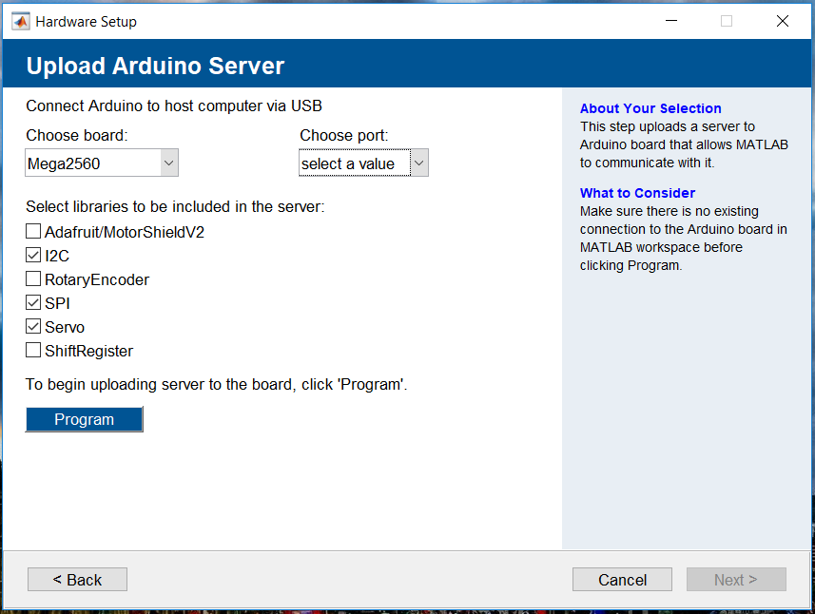
   3. Also include libraries you want to included and program your Arduino.
3. Set Simulation location External and simulation time infinite as shown below.`
4. Now go to Model Configuration Parameters and set it as shown below:
   1. Set Simulation Stop Time to Infinite(inf).
   2. Solver Typ: Fixed Step
   3. Solver :Discrete (recommended) or automatic
   4. Fixed Step size: 0.002 as sample time in digital input is 0.002

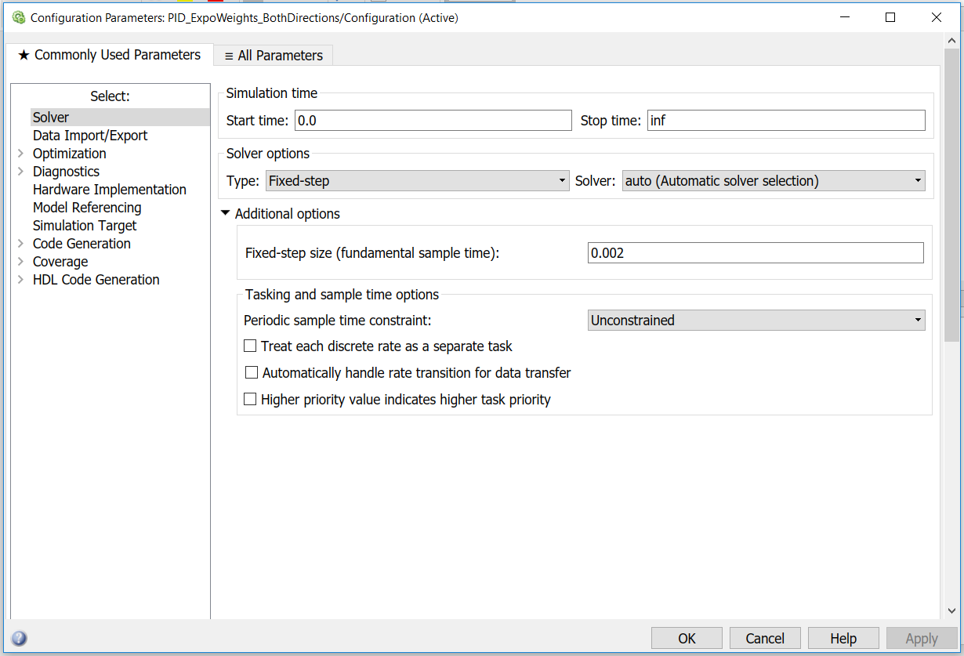

4.5 In Hardware Implementation choose your hardware board. 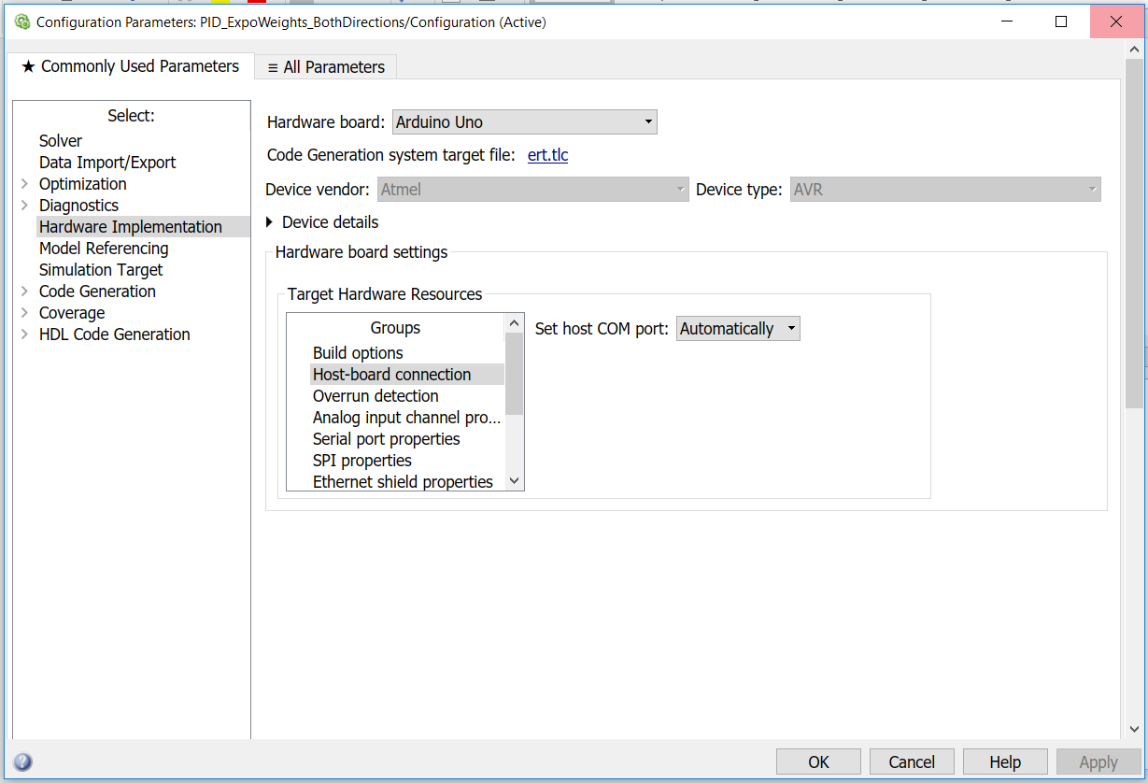

4.6 In Host-Board Connection COM port may be given manually or you can select automatically.

1. Before starting simulation make sure that your file is in current directory of MATLAB.

This image shows current directory of MATLAB.

1. If you get error like “Failed to generate all binary outputs” during building process change the folder of your .slx file and try again.
2. After this you will be able to simulate your model and you can see your inputs and output using scope or display block.

# USEFUL LINKS

* <https://in.mathworks.com/products/simulink.html?s_tid=hp_products_simulink>
* <https://www.youtube.com/watch?v=dbgWw90n_ys&list=PLJ1e5hCT22GqvlPaCAXMMSUTJ2Ci9Cx5b>
* <https://in.mathworks.com/help/supportpkg/arduinoio/ug/configure-setup-for-arduino-hardware.html>
* <https://in.mathworks.com/help/supportpkg/arduino/examples/arduino-robot-linefollower-application.html>
* https:/stratifylabs.co/embedded%20design%20tips/2013/10/15/Tips-Motor-Control-using-PWM-and-PID/